Brain Stroke Dataset: Random Forest Prediction Report

Overview
This document reports summaries and interpretations on factors identified as statistically significant to brain stroke using results from a Random Forest Model. The model used a “balanced” class weight to enhance sensitivity and performance metrics for practical medical screening purposes. The report captures dataset summaries, model summary tables, variable importance, accuracy tests, ROC Curve, and decision tree plot obtained using two programming languages, R and Python. The document ends with an interpretation of major statistics and overall conclusion on the significant predictors of stroke.

Data
Dataset | Observations | Stroke Cases | Stroke Rate (%)
Original | 4891 | 248 | 4.98%
Train | 2,491 | 123 | 4.94%
Test | 2,490 | 125 | 5.02%

- The original patient dataset was cleaned and split into 50% training set and 50% testing set using random data partitioning functions in R and Python libraries.
- The splitting algorithm ensured stroke rate was approximately similar between training and testing set.
- Only the training set was used for constructing forest models.
- The testing set was used to obtain predicted stroke probabilities and measure overall model performance.

Tuned Random Forest Model
Software used: R Studio, Spyder (Python)

Model Summary - R
Training time | 0.5090 seconds

Summary Table
Parameter | Value
Model Type | Random Forest Classification
Response Variable | Stroke
Training Observations | 2,491
Testing Observations | 2,490
Number of Trees (ntree) | 100
Variables Tried at Each Split (mtry) | 3
Class Weights | Class 0 = 1, Class 1 = 19
Importance Calculation | Enabled
OOB Accuracy | 94.66%
OOB Error Rate | 5.34%

Model Summary - Python
Training time | 0.2366 seconds
The training time of Python model is approximately half of the training time of R model

Summary Table
Parameter | Value
Model Type | Random Forest Classification
Training Observations | 2,491
Testing Observations | 2,490
Number of Trees (n_estimators) | 100
Maximum Tree Depth (max_depth) | 6
Class Weighting | Balanced
Random State | 42
Split Criterion | Gini Impurity
Features per Split | Auto (√p)
OOB Accuracy | 95.92%
OOB Error | 4.08%

Accuracy Tests

Accuracy Test - R
1. Threshold = 0.5
- Test Accuracy: 0.9490
- Sensitivity: 0.016
- Specificity: 0.9983
- Confusion Matrix:
Actual
Predicted | 0 | 1
0 | 2361 | 123
1 | 4 | 2

2. Best Threshold = 0.075
- Test Accuracy: 0.6598
- Sensitivity: 0.8080
- Specificity: 0.6520
- Confusion Matrix:
Actual
Predicted | 0 | 1
0 | 1542 | 24
1 | 823 | 101

- Key Observations:
  - Model detects 101 out of 125 actual stroke cases
  - Misses 24 out of 125 stroke cases
  - More false positives Overall accuracy dropped as the model predicts more observations as stroke
  - Substantially reduced false negatives higher sensitivity more suitable

Accuracy Test - Python
1. Threshold = 0.5
- Test Accuracy: 0.7884
- Sensitivity: 0.656
- Specificity: 0.7953
- Confusion Matrix:
Actual
Predicted | 0 | 1
0 | 1881 | 43
1 | 484 | 82

2. Best Threshold = 0.0721
- Test Accuracy: 0.7020
- Sensitivity: 0.808
- Specificity: 0.6964
- Confusion Matrix:
Actual
Predicted | 0 | 1
0 | 1647 | 24
1 | 718 | 101

- Key Observations:
  - Model detects 101 out of 125 actual stroke cases
  - Misses 24 out of 125 stroke cases
  - More false positives dropped accuracy (but not by a lot)

Model Comparisons:
Random Forest models were implemented in both R and Python using the same training and testing partitions. Both models used class weights to identify stroke cases, making it more suitable for medical screening applications by substantially reducing false negatives and increasing sensitivity. Despite minor implementation differences between the software packages, both models achieved comparable performance. Under similar thresholds (with a difference of 0.003), both models achieved identical sensitivity of 80.8%. The Python model produced 69.6% specificity, while the R model produced 65.2% specificity, which differs by about 4.4 percentage points. The accuracy also differs by about 4.2 percentage points. These results indicate consistent identification of stroke risk factors across platforms with minimal discrepancy. The main differences arise from implementation details such as tree depth restrictions, categorical variable handling, and class weighting rather than fundamental differences in predictive capability.
ROC Curves

ROC Curve (R):
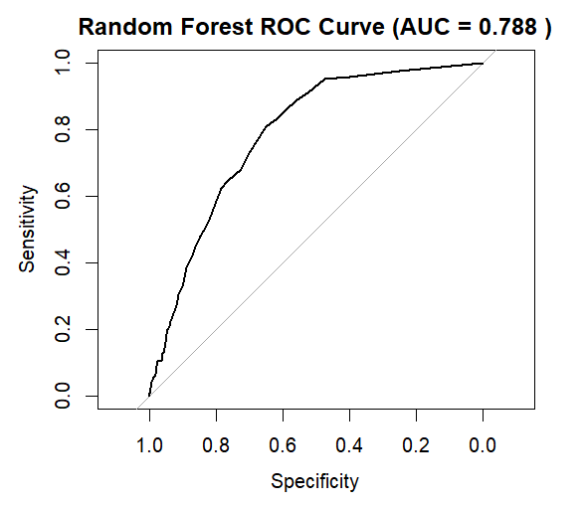

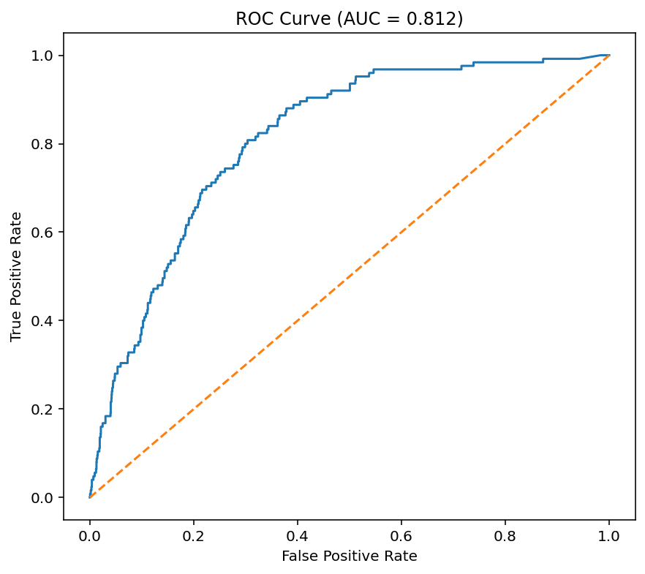
ROC Curve (Python):

Error Rate
Random Forest Error Rate Plot - R
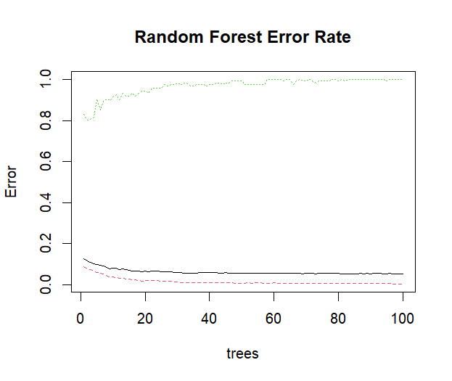

Variable Importance

Variable Importance - R

Rank | Variable | Mean Decrease Gini | Importance (%)
1 | age | 108.405 | 47.63%
2 | bmi | 36.848 | 16.19%
3 | avg_glucose_level | 33.792 | 14.85%
4 | work_type | 20.470 | 8.99%
5 | smoking_status | 14.015 | 6.16%
6 | ever_married | 3.813 | 1.68%
7 | Gender | 3.677 | 1.62%
8 | Residence_type | 3.656 | 1.61%
9 | hypertension | 1.587 | 0.70%
10 | heart_disease | 1.334 | 0.59%
Total |  | 227.598 | 100.00%
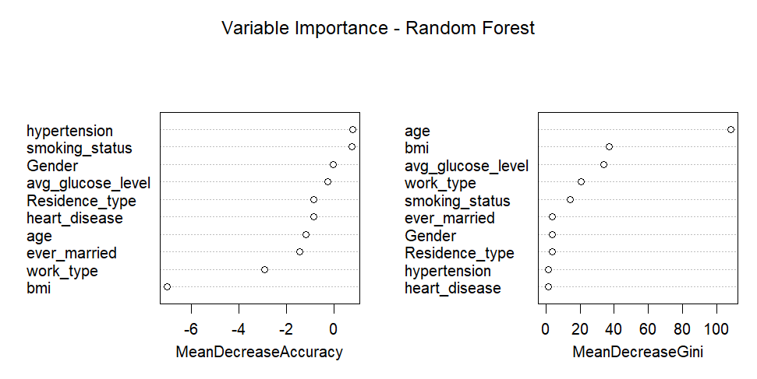

Variable Importance - Python
Rank | Variable | Importance | Importance (%)
1 | age | 0.489237 | 48.92%
2 | avg_glucose_level | 0.127159 | 12.72%
3 | bmi | 0.105354 | 10.54%
4 | hypertension_1 | 0.061344 | 6.13%
5 | ever_married_Yes | 0.056245 | 5.62%
6 | work_type_children | 0.037549 | 3.75%
7 | heart_disease_1 | 0.029821 | 2.98%
8 | smoking_status_never smoked | 0.016268 | 1.63%
9 | work_type_Self-employed | 0.016172 | 1.62%
10 | work_type_Private | 0.014209 | 1.42%
11 | smoking_status_smokes | 0.013645 | 1.36%
12 | Gender_Male | 0.013434 | 1.34%
13 | Residence_type_Urban | 0.010928 | 1.09%
14 | smoking_status_formerly smoked | 0.008636 | 0.86%

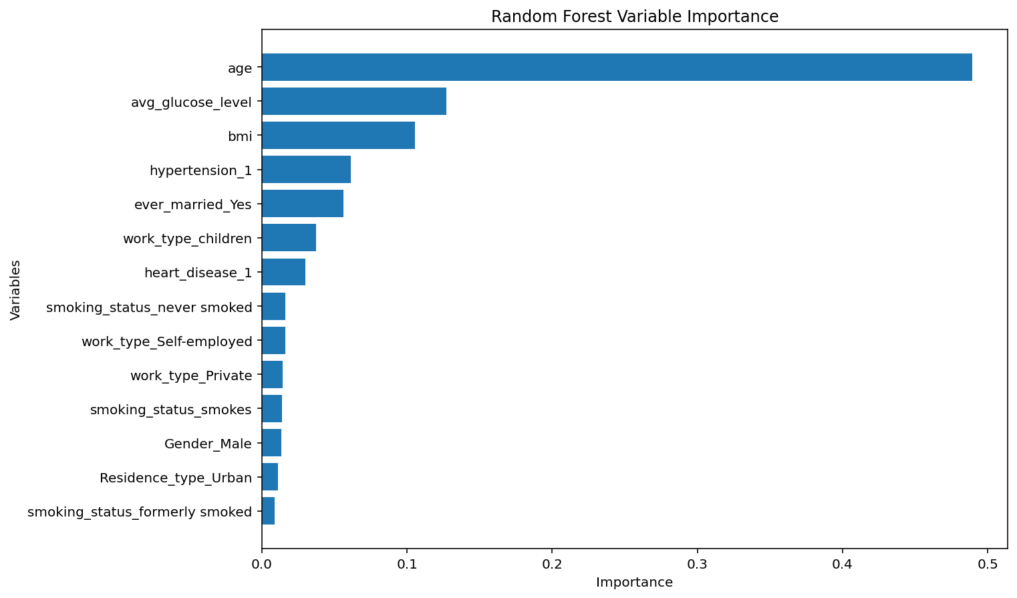
Key Observations
- The variable importance was derived from class-weighted models, obtained by modifying the original models, which focused heavily on the majority (non-stroke cases) to improve performance metrics and stroke detection in an imbalanced dataset.
- Both R and Python class-weighted models identify three dominant predictors:

- Age: Age achieves an overwhelmingly high variable importance score (~47-49%) in both models. This suggests that age is one of the strongest variables for distinguishing stroke from non-stroke patients in the dataset.
- Average Glucose Level consistently appears among the top three variables in both forests with variable importance score of ~12-14%.
- BMI comes in close tie with average glucose level as a dominant predictor.

- Hypertension has moderate contribution in the Python forest, but its ranking dropped in the R forest.
- Smoking Status and Marriage Status are recognized to have more significant effect than they did in the earlier models (Decision tree and Logistic regression)

Confusion Matrix

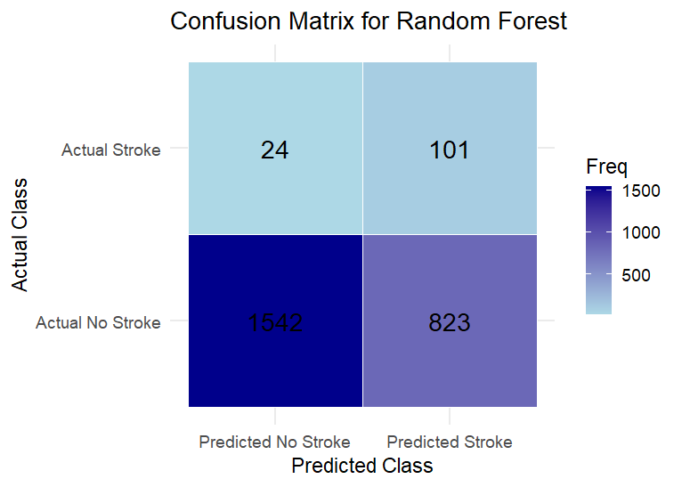
Confusion Matrix Heatmap - R

Confusion Matrix Heatmap - Python
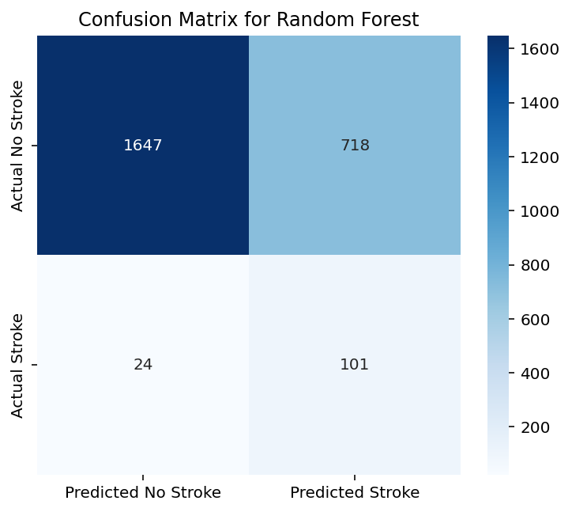

Train vs Test Accuracy
Software | Train Accuracy | Test Accuracy
R | 1.0000 | 0.6598
Python | 0.8222 | 0.702

Key Observations
- The R Random Forest achieved perfect training accuracy, but there is a substantial drop from 100% training accuracy to 65.98% test accuracy. This suggests significant overfitting (model captures relationships specific to the training rather than general patterns).
- Python Random Forest exhibited a much smaller gap between the train and test accuracies, providing a better balance between learning the training data and maintaining predictive performance on new observations.
- Although Python was less accurate on the training set, it achieved higher test accuracy, which suggests that it is more suitable for prediction.

Out-Of-Bag Score
Software | OOB Accuracy | OOB Error
R | 94.66% | 5.34%
Python | 95.02% | 4.08%

Key Observations:
- Both models achieved very high OOB accuracy (>94%), indicating that they classify the majority class (non-stroke cases) effectively.
- The Python model produced slightly better OOB scores (higher accuracy, lower error rate).
- The OOB scores are heavily influenced by the class imbalance in the dataset (approximately 95% non-stroke and 5% stroke cases), so they must be interpreted alongside sensitivity and specificity.

